

Sunday, December 14, 2025

Pilgrim Evangelical Lutheran Church (WELS)
W156 N5436 Bette Drive, Menomonee Falls, WI | 262-781-3520 | office@pilgrimcares.org
Worship services - Wednesday 6:30pm, Sunday 8:00 and 10:30am

Another service popularized by King’s College is An Advent Carol Service, also known as A Procession of Carols on Advent Sunday. The service breathes the air of Advent, not Christmas, and was designed for use on a Sunday in Advent. The service includes six readings instead of nine, and their selection is not as established as those of the Christmas service. Several congregational hymns are invariably included. As at Christmas, the choir may add a variety of anthems and carols.

Jesus said, “Let the little children come to me, and do not hinder them, for the kingdom of heaven belongs to such as these.” We know that keeping little children occupied for an entire church service can be a challenge. Don’t worry; most of those worshiping around you have been in your shoes at one time. If you feel that you need to take your child out of church at any time, we have a Children’s Room to the right as you exit the worship area. The first parking space in front of church is designated for expectant mothers and families with small children.
Restrooms are located to your left as you exit the worship area. There are changing tables in both restrooms.
LARGE PRINT copies of worship materials are available from the ushers. If you have any questions or need assistance, please feel free to ask an usher.

Serving In Worship
Presiding Minister Pastor Collin Vanderhoof
Preacher Pastor Aaron Winkelman
Organist Amy Balza, David Porth, Joel Schwartz
Instrumentalists Ethan Balza, Allie Bauer
The Service, Setting Four

Hymn
O Lord, how shall I meet you,
How welcome you aright?
Your people long to greet you,
My hope, my heart’s delight!
O kindle, Lord, most holy,
Your lamp within my breast
To do in spirit lowly
All that may please you best.
See, Zion casts before you
Green boughs and fairest palms,
And I, too, will adore you
With joyous songs and psalms.
My heart shall bloom forever
For you with praises new
And from your name shall never
Withhold the honor due.

Please stand

Invocation
In the name of the Father and of the ☩ Son and of the Holy Spirit.
Amen.

Confession of Sins
Beloved in the Lord: let us draw near with a true heart and confess our sins to God our Father, asking him in the name of our Lord Jesus Christ to grant us forgiveness.
Holy and merciful Father, I confess that I am by nature sinful and that I have disobeyed you in my thoughts, words, and actions. I have done what is evil and failed to do what is good. For this I deserve your punishment both now and in eternity. But I am truly sorry for my sins, and trusting in my Savior Jesus Christ, I pray: Lord, have mercy on me, a sinner.
I lay in fetters, groaning,
You come to set me free;
I stood, my shame bemoaning
You come to honor me;
A glory you do give me,
A treasure safe on high,
That will not fail or leave me
As earthly riches fly.

Absolution
God, our heavenly Father, has been merciful to us and has given his only Son to be the atoning sacrifice for our sins. Therefore, as a called servant of Christ and by his authority, I forgive you all your sins in the name of the Father and of the Son ☩ and of the Holy Spirit.
Amen.
Sin’s debt, that fearful burden,
Let not your souls distress;
Your guilt the Lord will pardon
And cover by his grace.
He comes, for you procuring
The peace of sin forgiv’n,
His children thus securing
A heritage in heav’n.

Lighting of the Advent Wreath
Advent 3
We light three Advent candles remembering Jesus, the Light of the world. He came to defeat the prince of darkness.
We remember Jesus, who came in answer to his people’s prayers. John proclaimed him the Lamb of God, who takes away the sin of the world.
We hear his call to see the light.
We light three Advent candles as a sign of our trust and confidence.
Come, Lord Jesus, be our guest.
Through your Word and Spirit may our souls be blessed.
Three Advent candles are lit as the following stanza is sung:
What though the foes be raging,
Heed not their craft and spite;
Your Lord, the battle waging,
Will scatter all their might.
He comes, a King most glorious,
And all his earthly foes
In vain his course victorious
Endeavor to oppose.
Sermon

Prayer of the Day
Let us pray.

Hear our prayers, Lord Jesus Christ, and come with the good news of your mighty deliverance. Drive the darkness from our hearts, and fill us with your light; for you live and reign with the Father and the Holy Spirit, one God, now and forever.
Amen.

Rejoice, then, you sad-hearted,
Who sit in deepest gloom,
Who mourn o’er joys departed
And tremble at your doom.
Despair not; he is near you,
He’s standing at the door
Who best can help and cheer you
And bids you weep no more.
Lord’s Prayer
Our Father in heaven,
hallowed be your name,
your kingdom come,
your will be done
on earth as in heaven.
Give us today our daily bread.
Forgive us our sins,
as we forgive those
who sin against us.
Lead us not into temptation,
but deliver us from evil.
For the kingdom, the power,
and the glory are yours
now and forever. Amen.
Be seated

Lesson Isaiah 40:1–8
The prophet foretells the coming of the glory of the Lord.

¹Comfort, comfort my people,
says your God.
²Speak tenderly to Jerusalem,
and proclaim to her
that her hard service has been completed,
that her sin has been paid for,
that she has received from the Lord’s hand
double for all her sins.
³A voice of one calling:
“In the wilderness prepare
the way for the Lord;
make straight in the desert
a highway for our God.
⁴Every valley shall be raised up,
every mountain and hill made low;
the rough ground shall become level,
the rugged places a plain.
⁵And the glory of the Lord will be revealed,
and all people will see it together.
For the mouth of the Lord has spoken.”
⁶A voice says, “Cry out.”
And I said, “What shall I cry?”
“All people are like grass,
and all their faithfulness is like the flowers of the field.
⁷The grass withers and the flowers fall,
because the breath of the Lord blows on them.
Surely the people are grass.
⁸The grass withers and the flowers fall,
but the word of our God endures forever.”

The Word of the Lord.
Thanks be to God.

Comfort, Comfort All My People CW 312 sts. 1, 3–4
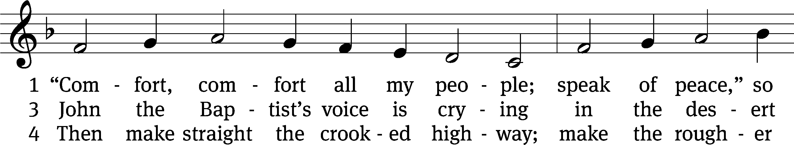
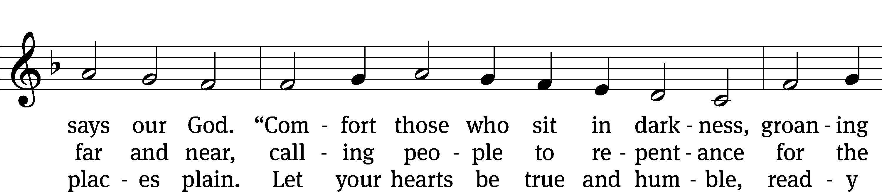
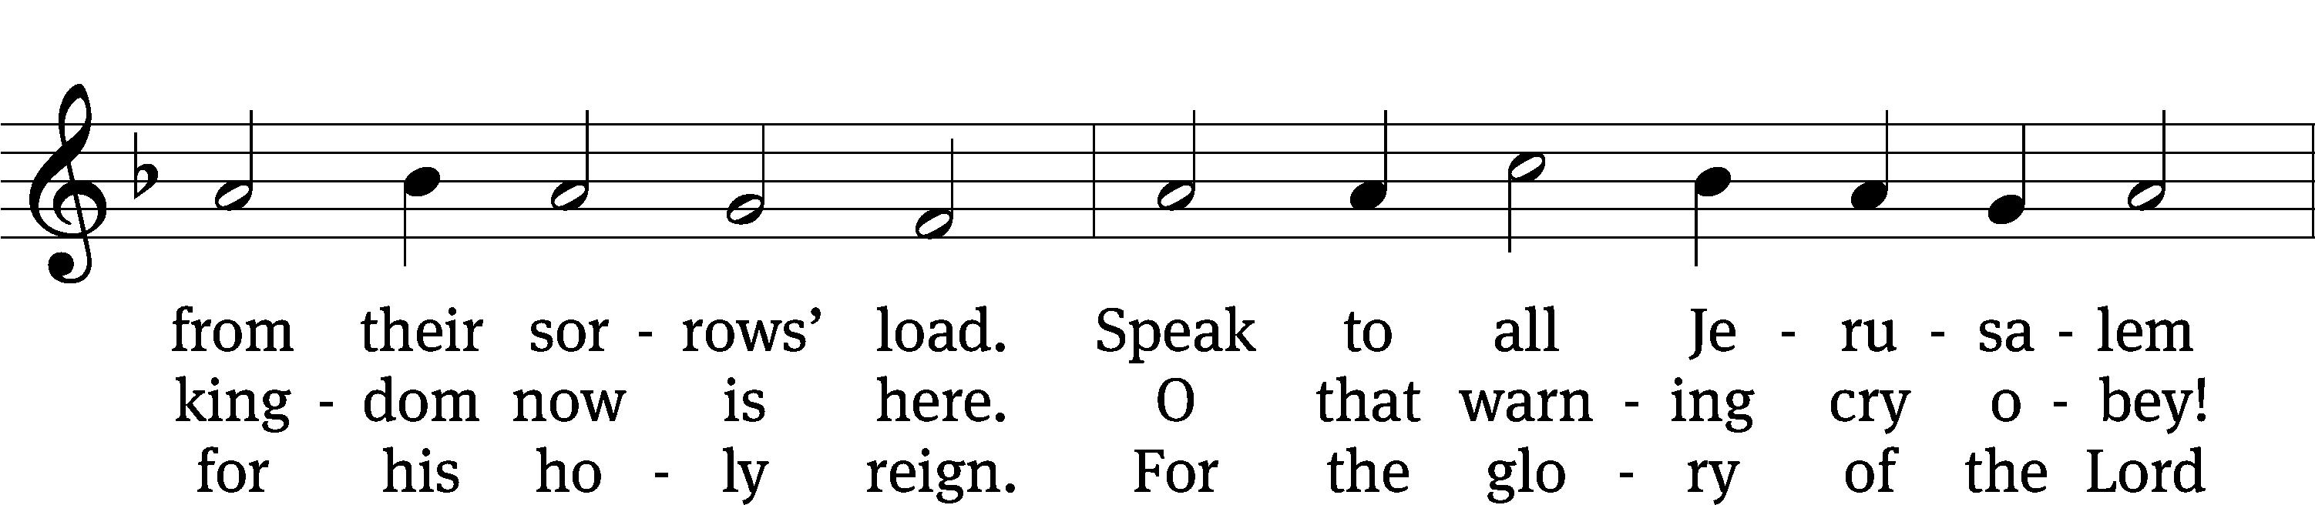
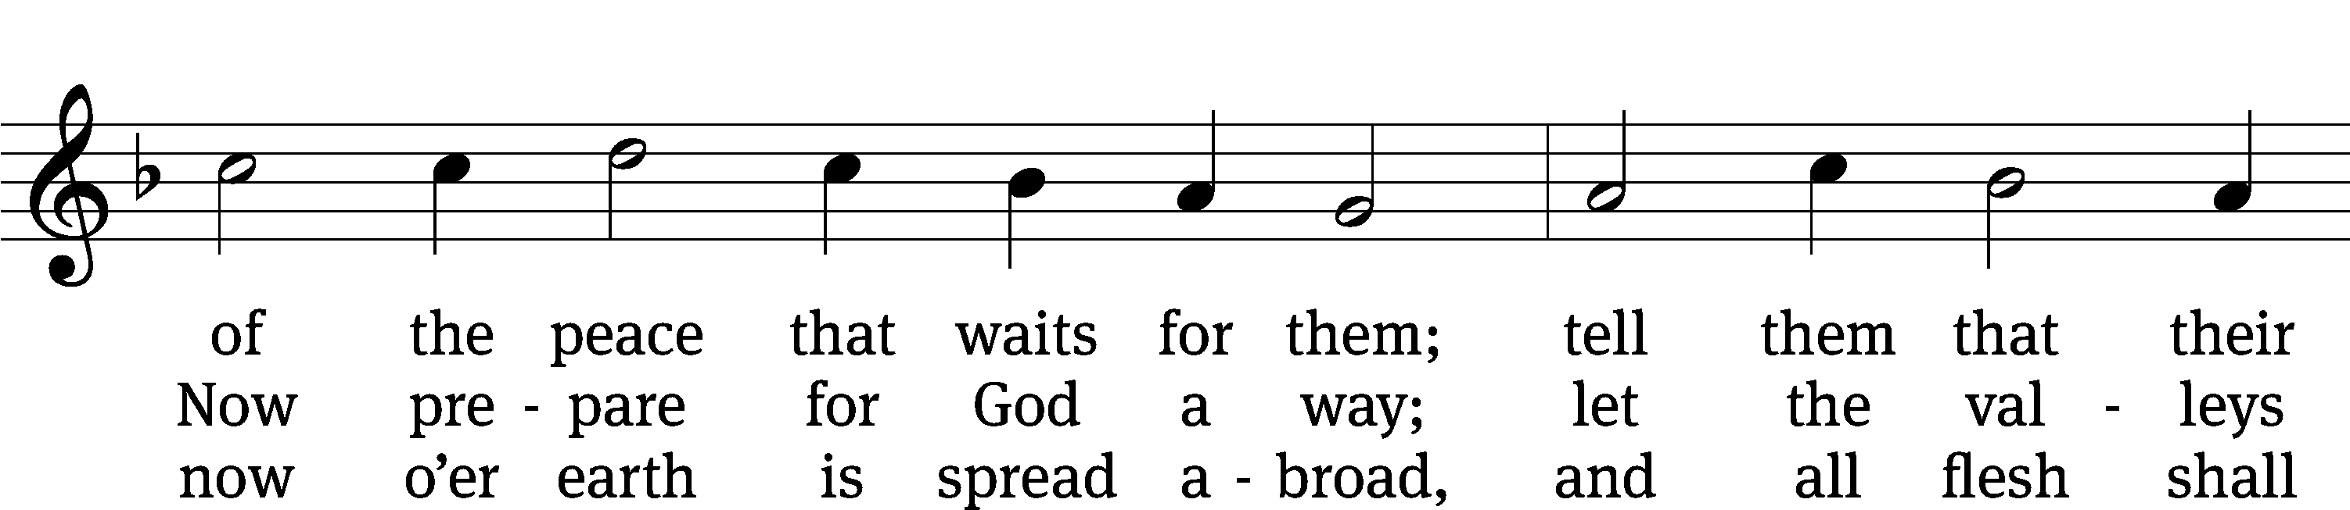
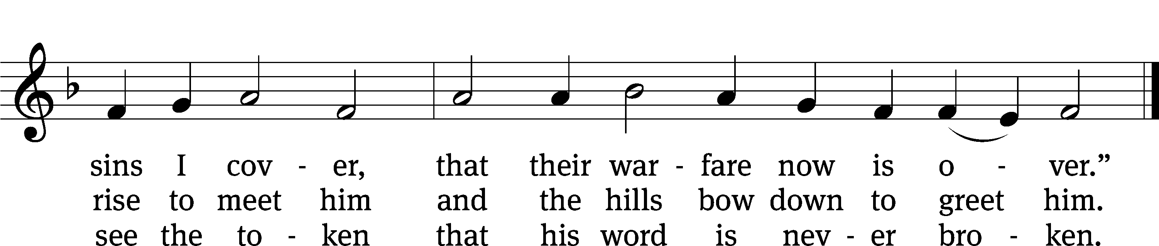
Text: Johann G. Olearius, 1611–1684; tr. Catherine Winkworth, 1827–1878, alt. Tune: Trente quatre Pseaumes de David, Geneva, 1551, ed. Louis Bourgeois Text and tune: Public domain

Lesson Jeremiah 23:5, 6
The Lord promises to send a Righteous Savior.
⁵“The days are coming,” declares the Lord,
“when I will raise up for David a righteous Branch,
a King who will reign wisely
and do what is just and right in the land.
⁶In his days Judah will be saved
and Israel will live in safety.
This is the name by which he will be called:
The Lord Our Righteous Savior.
The Word of the Lord.
Thanks be to God.
Anthem Lift up Your Heads John L. Hopkins
Lift up your heads, O ye gates,
and be ye lift up, ye everlasting doors:
and the King of glory shall come in.

Who is the King, the King of glory?
The Lord strong and mighty, mighty in battle.

The Lord of Hosts; He is the King of Glory.
Lesson Haggai 2:6–9
The desire of all nations will come.
⁶“This is what the Lord Almighty says: ‘In a little while I will once more shake the heavens and the earth, the sea and the dry land. ⁷I will shake all nations, and what is desired by all nations will come, and I will fill this house with glory,’ says the Lord Almighty. ⁸‘The silver is mine and the gold is mine,’ declares the Lord Almighty. ⁹‘The glory of this present house will be greater than the glory of the former house,’ says the Lord Almighty. ‘And in this place I will grant peace,’ declares the Lord Almighty.”
The Word of the Lord.
Thanks be to God.
O Jesus, Grant Me Hope and Comfort CW 326
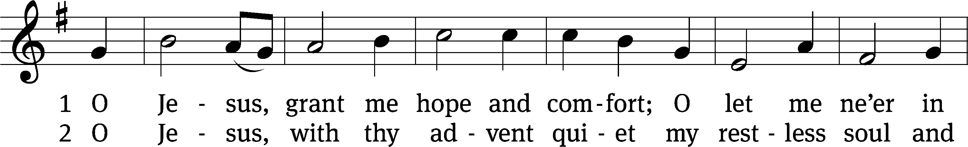
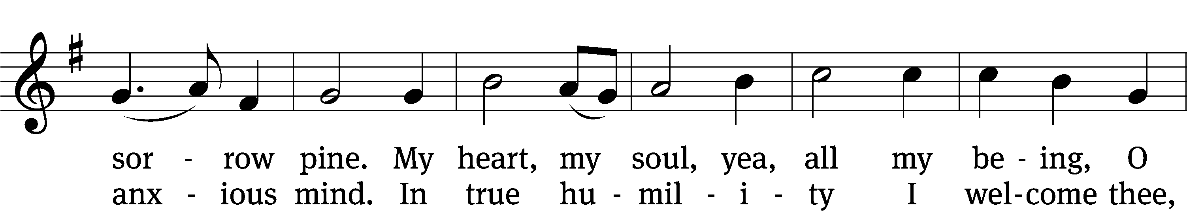
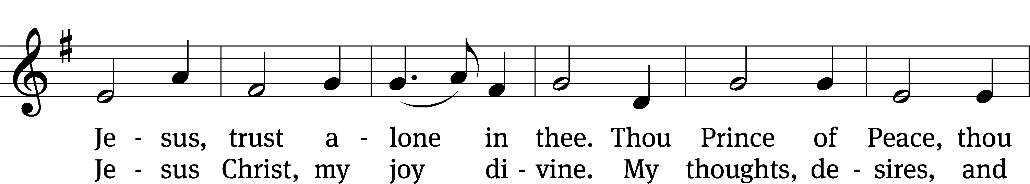
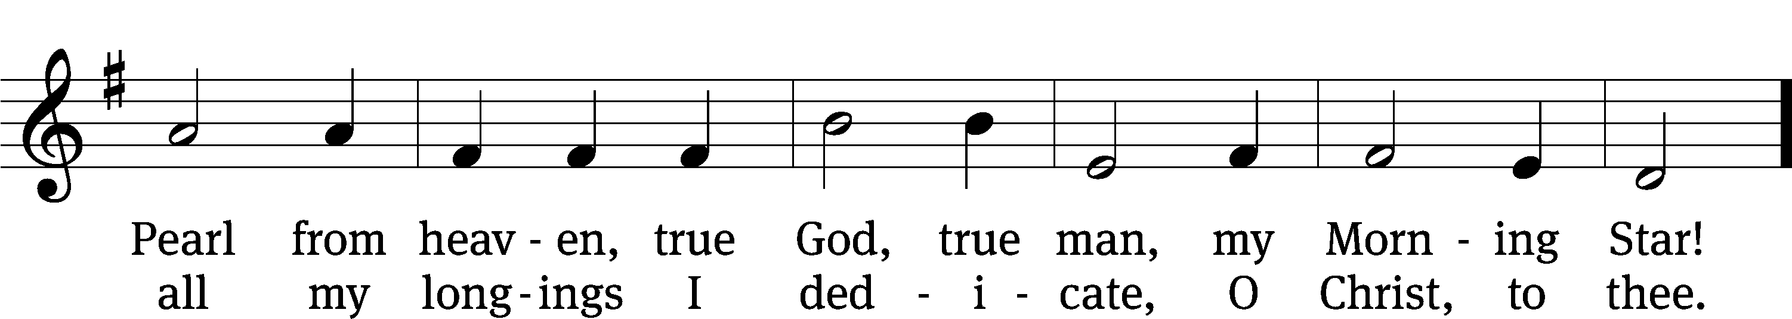
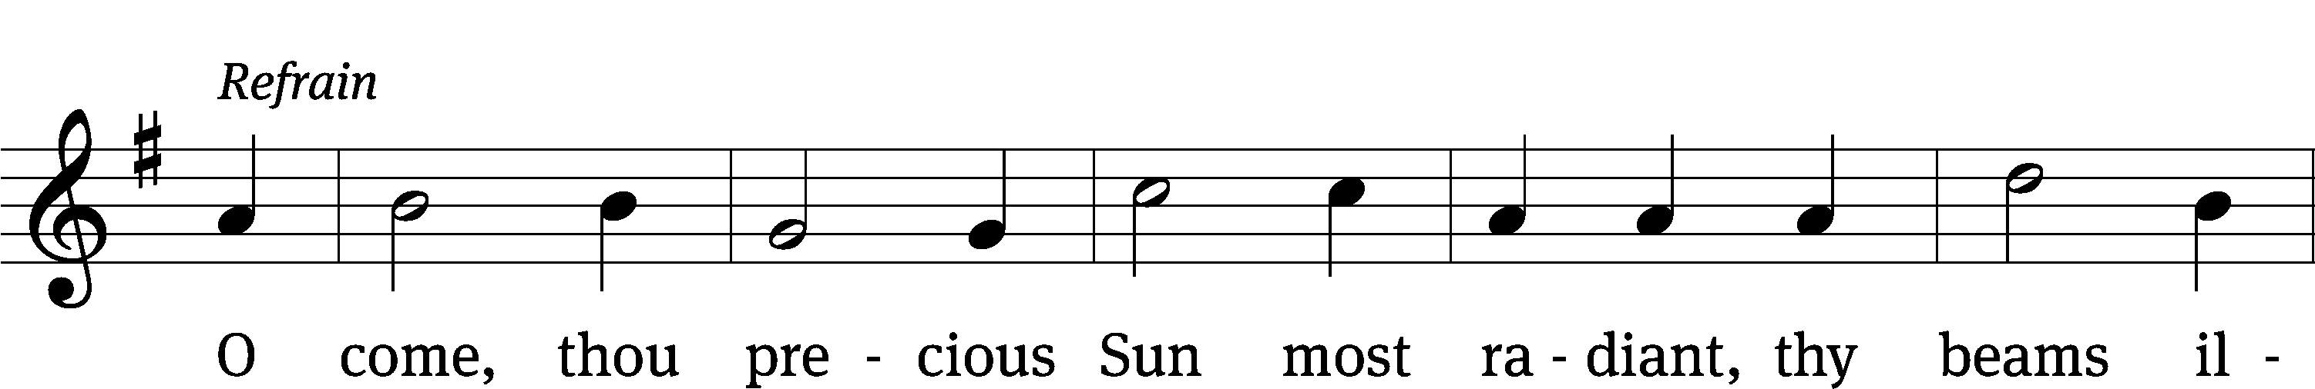
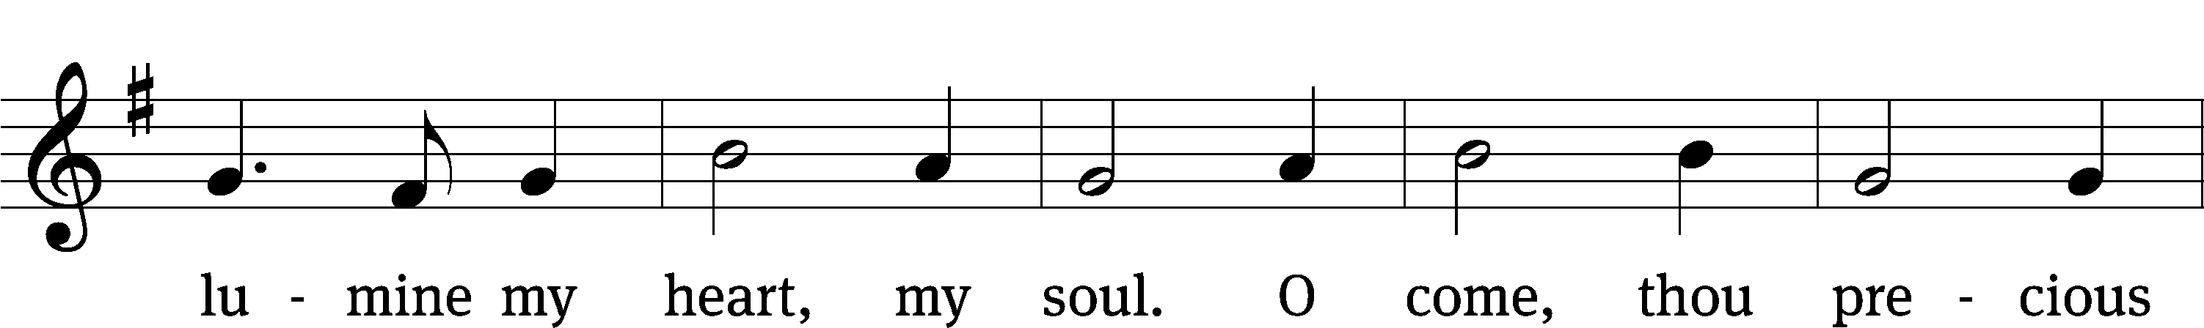
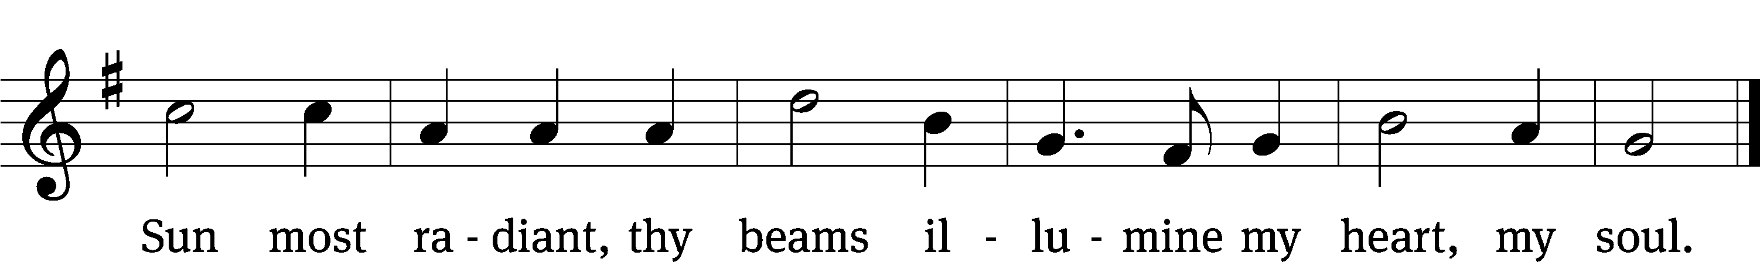
Text: Wilhelm Osterwald, 1820–1887; tr. Walter E. Buszin, 1899–1973 Tune: Johann Franck, 1618–1677 Text: © 1939 Paul A. Schmitt Music Co.; ren. 1967 Schmitt, Hall & McCreary Company All rights assigned to and owned by Jubilate Music Group, LLC. Used by permission: OneLicense no. 712872
Tune: Public domain

Lesson Isaiah 35:1–6
The joy of the redeemed.
¹The desert and the parched land will be glad;
the wilderness will rejoice and blossom.
Like the crocus, ²it will burst into bloom;
it will rejoice greatly and shout for joy.
The glory of Lebanon will be given to it,
the splendor of Carmel and Sharon;
they will see the glory of the Lord,
the splendor of our God.
³Strengthen the feeble hands,
steady the knees that give way;
⁴say to those with fearful hearts,
“Be strong, do not fear;
your God will come,
he will come with vengeance;
with divine retribution
he will come to save you.”
⁵Then will the eyes of the blind be opened
and the ears of the deaf unstopped.
⁶Then will the lame leap like a deer,
and the mute tongue shout for joy.
Water will gush forth in the wilderness
and streams in the desert.

The Word of the Lord.
Thanks be to God.

Wake, Awake, for Night Is Flying CW 486
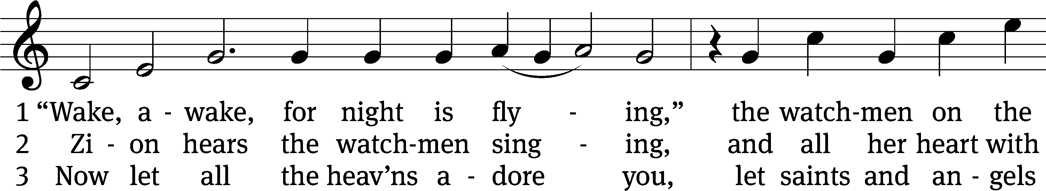
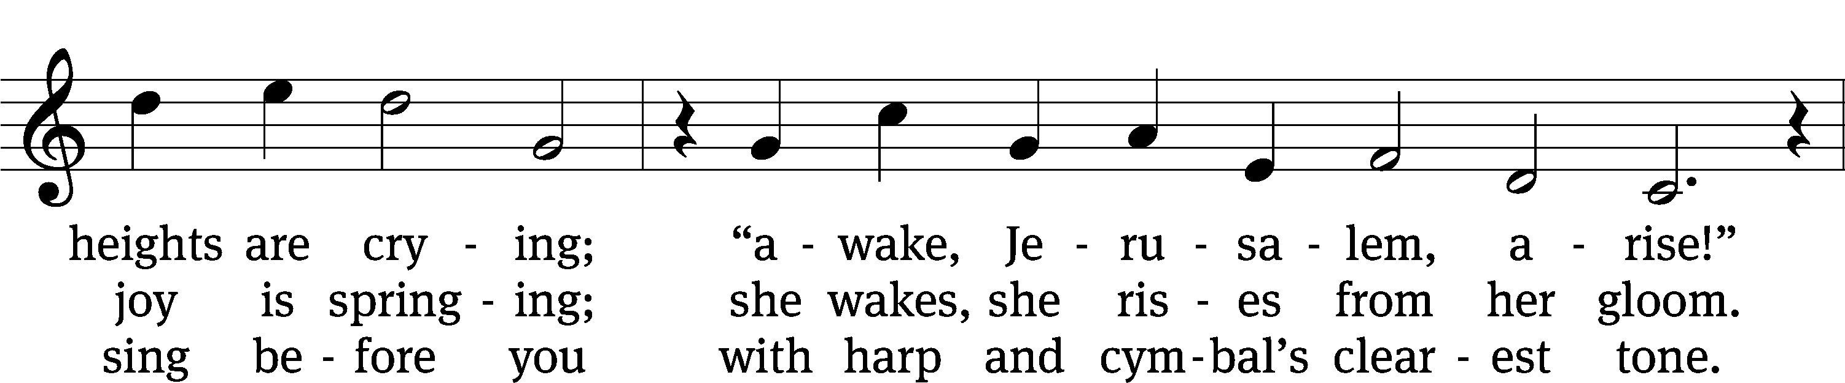
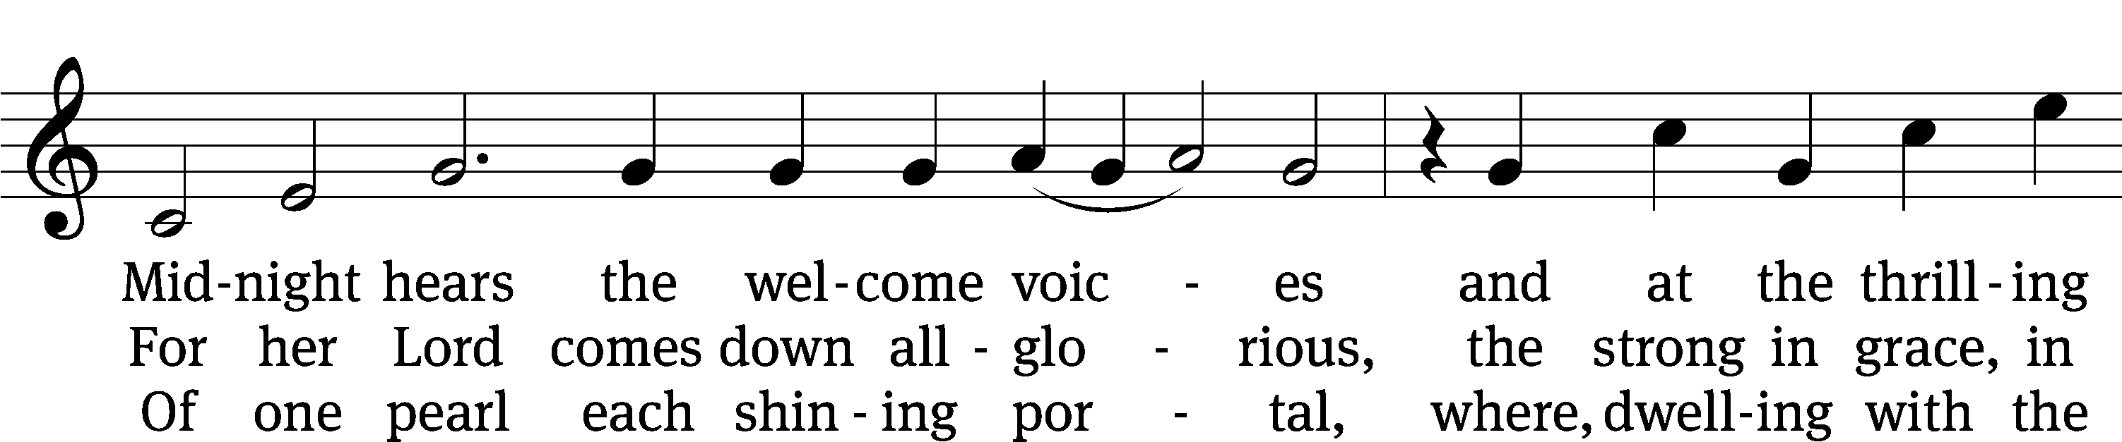
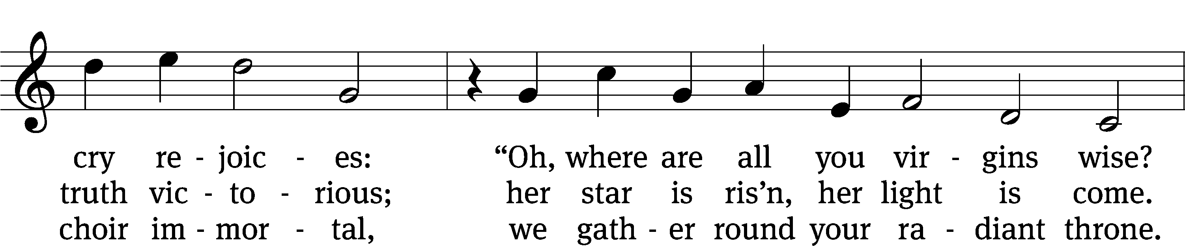
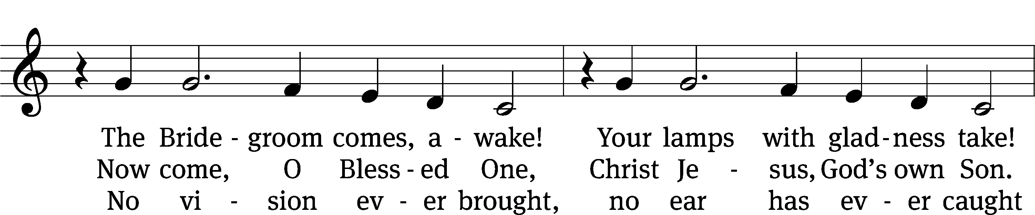
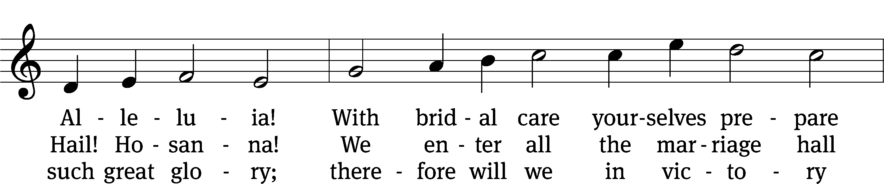
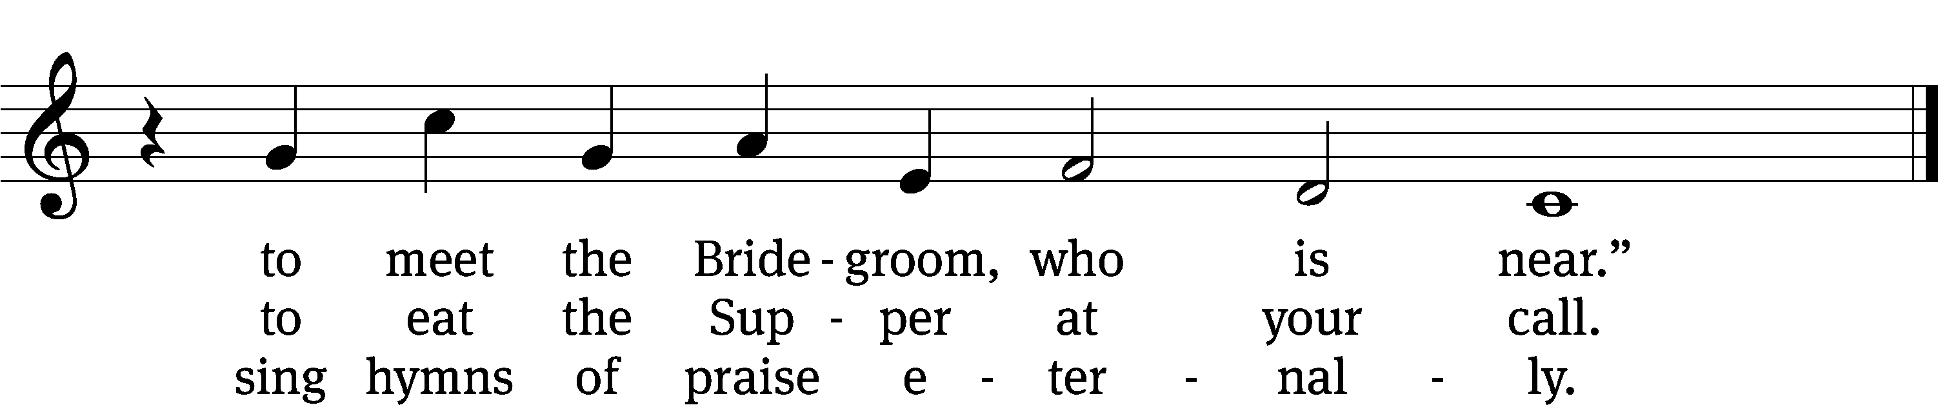
Lesson Luke 1:26–35, 38
The angel Gabriel announces to Mary the birth of a son.

²⁶In the sixth month of Elizabeth’s pregnancy, God sent the angel Gabriel to Nazareth, a town in Galilee, ²⁷to a virgin pledged to be married to a man named Joseph, a descendant of David. The virgin’s name was Mary. ²⁸The angel went to her and said, “Greetings, you who are highly favored! The Lord is with you.”
²⁹Mary was greatly troubled at his words and wondered what kind of greeting this might be. ³⁰But the angel said to her, “Do not be afraid, Mary; you have found favor with God. ³¹You will conceive and give birth to a son, and you are to call him Jesus. ³²He will be great and will be called the Son of the Most High. The Lord God will give him the throne of his father David, ³³and he will reign over Jacob’s descendants forever; his kingdom will never end.”
³⁴“How will this be,” Mary asked the angel, “since I am a virgin?”
³⁵The angel answered, “The Holy Spirit will come on you, and the power of the Most High will overshadow you. So the holy one to be born will be called the Son of God.
³⁸“I am the Lord’s servant,” Mary answered. “May your word to me be fulfilled.” Then the angel left her.
The Word of the Lord.
Thanks be to God.

Love Has Come CW 364
The choir will sing stanza one.
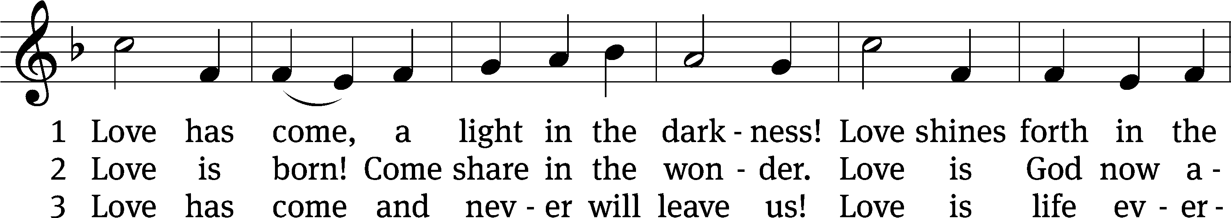
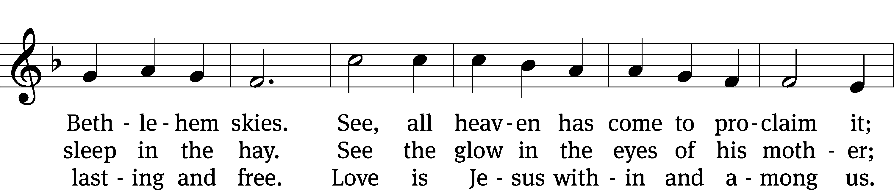
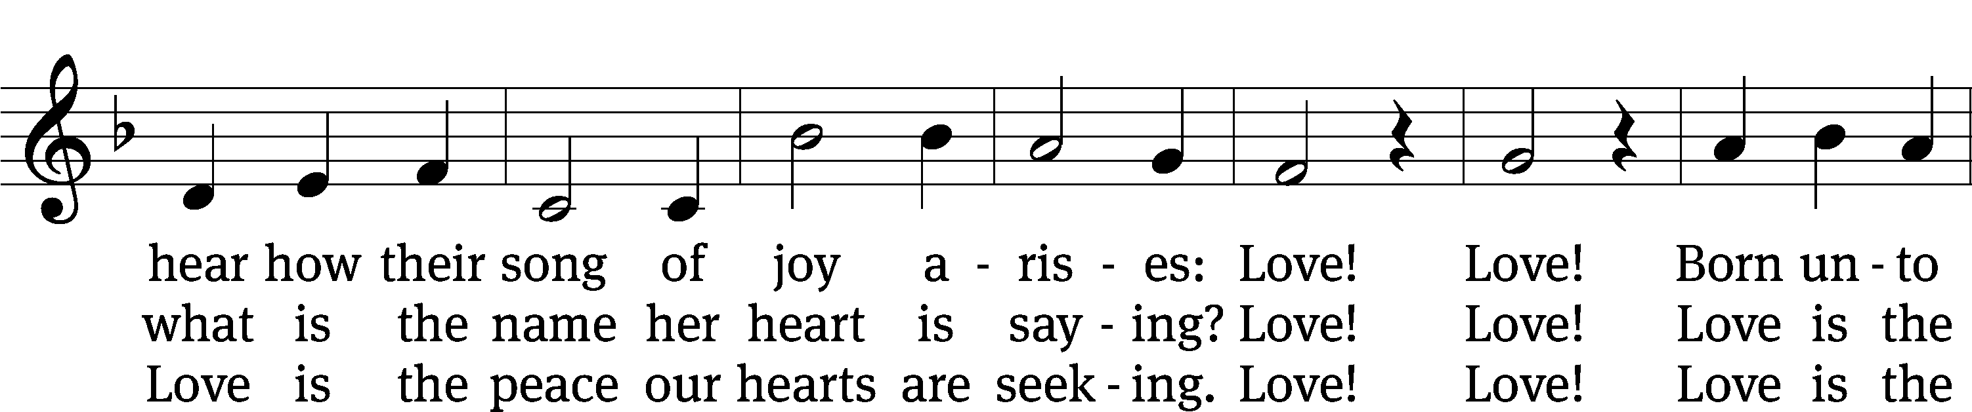
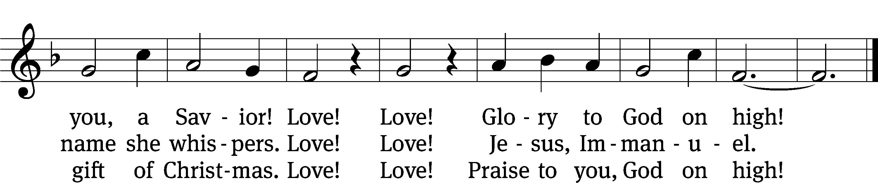
Text: Ken Bible, b. 1950 Tune: F. Seguin, Recueil de noëls composés en langue provençale, 1856 Text: © 1996 LNW Hymns, admin. Music Services, Inc. Used by permission: OneLicense no. 712872 Tune: Public domain

Stand
Lesson Mark 1:1–4, 7–15
The coming of the kingdom of God.
¹The beginning of the good news about Jesus the Messiah, the Son of God, ²as it is written in Isaiah the prophet:
“I will send my messenger ahead of you,
who will prepare your way”—
³“a voice of one calling in the wilderness,
‘Prepare the way for the Lord,
make straight paths for him.’ ”
⁴And so John the Baptist appeared in the wilderness, preaching a baptism of repentance for the forgiveness of sins.
⁷And this was his message: “After me comes the one more powerful than I, the straps of whose sandals I am not worthy to stoop down and untie. ⁸I baptize you with water, but he will baptize you with the Holy Spirit.”
⁹At that time Jesus came from Nazareth in Galilee and was baptized by John in the Jordan. ¹⁰Just as Jesus was coming up out of the water, he saw heaven being torn open and the Spirit descending on him like a dove. ¹¹And a voice came from heaven: “You are my Son, whom I love; with you I am well pleased.”
¹²At once the Spirit sent him out into the wilderness, ¹³and he was in the wilderness forty days, being tempted by Satan. He was with the wild animals, and angels attended him.
¹⁴After John was put in prison, Jesus went into Galilee, proclaiming the good news of God. ¹⁵“The time has come,” he said. “The kingdom of God has come near. Repent and believe the good news!”
The Word of the Lord.
Thanks be to God.
Be seated

Anthem Prepare the Royal Highway
Zebulon Highben
Prepare the royal highway;
the King of kings is near!
Let ev’ry hill and valley
a level road appear!
Then greet the King of glory,
foretold in sacred story: (Refrain)

Refrain: Hosanna to the Lord,
for he fulfills God’s Word!

Then fling the gates wide open
to greet your promised King!
Your King, yet ev’ry nation
its tribute too may bring.
All lands, will bow before him!
Their voices join your singing! (Refrain)

His is no earthly kingdom;
it comes from heav’n above.
His rule is peace and freedom
and justice, truth, and love.
So let your praise be sounding
for kindness so abounding: (Refrain)
Prayer of the Church
Let us pray.
Eternal Father, throughout the centuries you repeated and affirmed your promise to send the offspring of the woman to crush the serpent’s head. Through your prophets of old, you continually directed the eyes of your people to the advent of their Savior.
We praise you, O Lord, for keeping your promise and sending your Son to destroy the works of the devil.

As we prepare to celebrate the birth of our King, use your mighty Word to shatter our pride and to rouse us from spiritual slumber and apathy.
Move us to take to heart the words of John: “Repent, for the kingdom of heaven is near.”
You sent your Son to redeem us from sin. Let this good news be our joy and strength. Use it to cheer the lonely, encourage the fearful, and give hope to the despairing. In these days before Christmas, spare us from the stress of deadlines and the frenzy of commercialism.
Fill our lives with the message of your peace and the music of your grace.

Direct our eyes not only to the manger but also to the skies, where we will see your Son coming again, not as a lowly child but as the Lord of lords.
Lift up our hearts in joyful anticipation of that day.

Hear us, Lord, as we bring you our private petitions.

Come quickly, Lord Jesus, in your grace, in your power, and in your glory.
Come, Lord Jesus!
Amen.
Anthem For Unto Us a Child is Born
George Frideric Handel

“For unto us a child is born, unto us a son is given: and the government shall be upon his shoulder: and his name shall be called Wonderful, Counselor, The mighty God, The everlasting Father, The Prince of Peace.”

– Isaiah 9:6

Blessing
Christ the Sun of Righteousness shine upon you, scatter the darkness from before your path, and make you ready to meet him when he comes in glory, and the blessing of God Almighty, the Father, the T Son and the Holy Spirit, be upon you and remain with you always.
Amen.
Arise, O Christian People CW 310
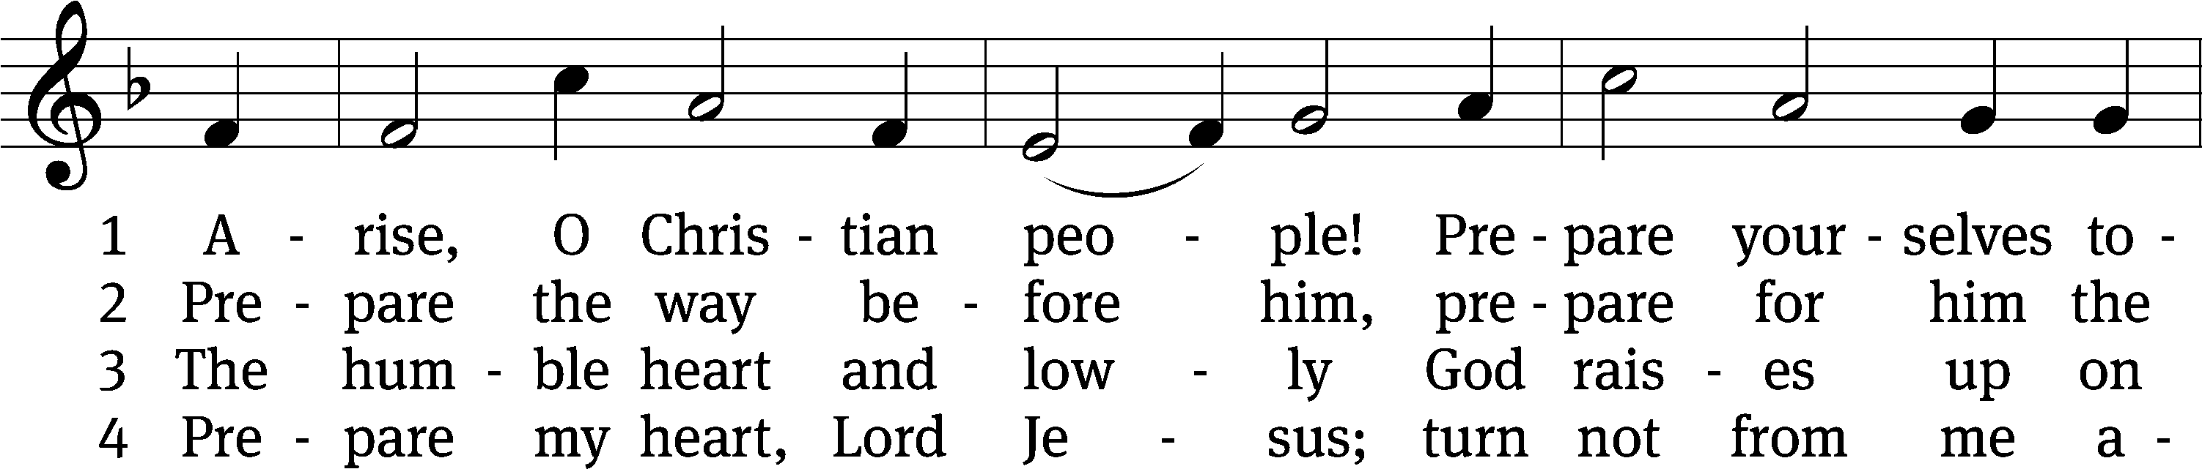
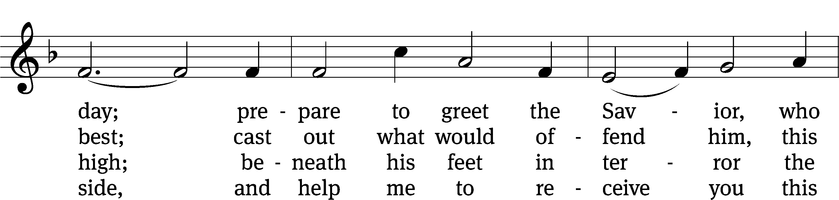
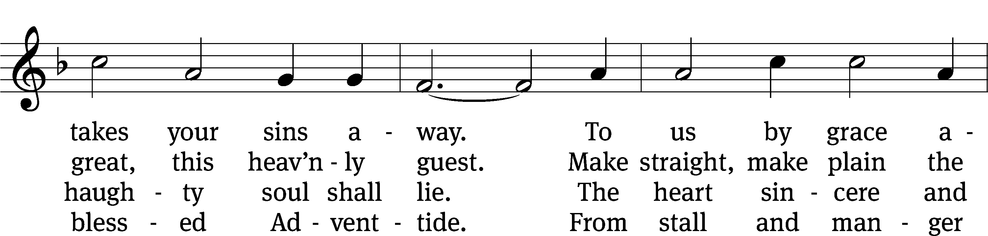
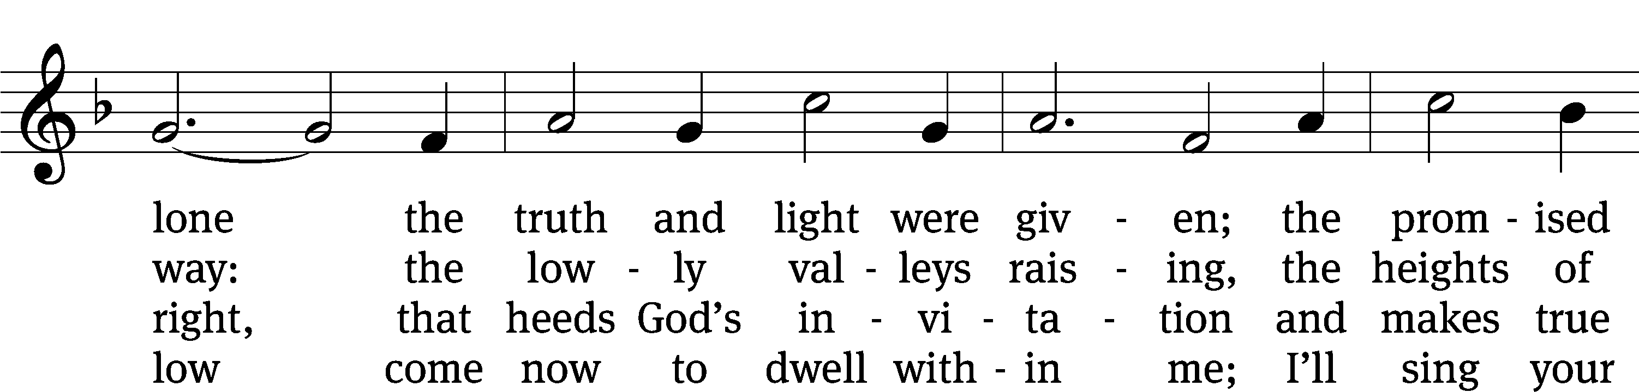
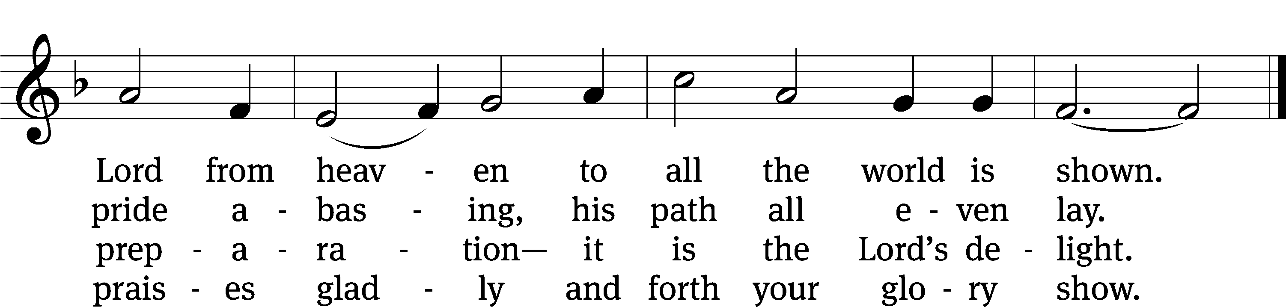
Text: Valentin Thilo, 1607–1662; (sts. 1–3): tr. Arthur T. Russell, 1806–1874, alt.; (st. 4): tr. unknown, alt.
Tune: New Catechismus Gesangbüchlein, Hamburg, 1598, alt.
Text and tune: Public domain

8:00am 10:30am
Ushers
12-14 Matt Lawonn Jim Prekop
Sean Kappl Alec Delvaux
12-21 Jim Prekop Glen Kuphall
Tim Pankow Josh Weber

Worship Hosts
12-14 Irene Lape & Pat Knack Marge Ekstowicz & Elke Warren
12-21 Bill & LaVonne Kirchner Joel & Jenny Raasch
Attendance
12-3 103 + 46 = 149
12-7 78 + 131 = 209


Pilgrim Lutheran Church can receive offerings electronically through a secure website. Scan the QR code with your smart phone (you might need to download a free QR scanning app) to be directed to Pilgrim’s giving page or visit pilgrimcares.org/giving. Save the check – give online!

Pilgrim’s Advent and Christmas Schedule
December 3, 10, 17 Midweek Advent Services - 3:30pm and 6:30pm
December 14 8:00am and 10:30am Advent Song Service
December 21 10:30am Children’s Christmas Service in the gym
8:00am Divine Service in Church
December 24 4:30pm Lessons & Carols
6:30pm Candlelight Service
December 25 8:15am to 8:45am Hymn Sing
9:00am Christmas Day Festival Service with Holy Communion
No Wednesday Evening Worship on December 31

Pilgrimcares.org

Pastor Collin Vanderhoof Pastor Aaron Winkelman
cvanderhoof@pilgrimcares.org awinkelman@pilgrimcares.org
608.548.0670 219.380.2212

Pastor Greg Hermanson Principal Kevin Klug
pastorhermanson@gmail.com kklug@pilgrimcares.org
262.505.4377 920.253.7688
Early Childhood Director Amanda Berg
aberg@pilgrimcares.org
507.829.7267

